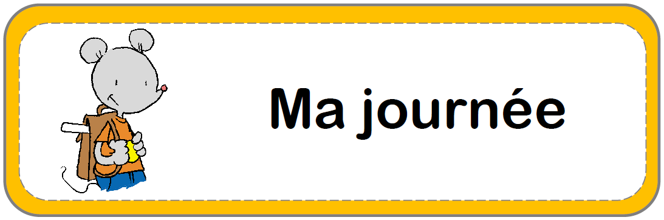

Daily Schedule

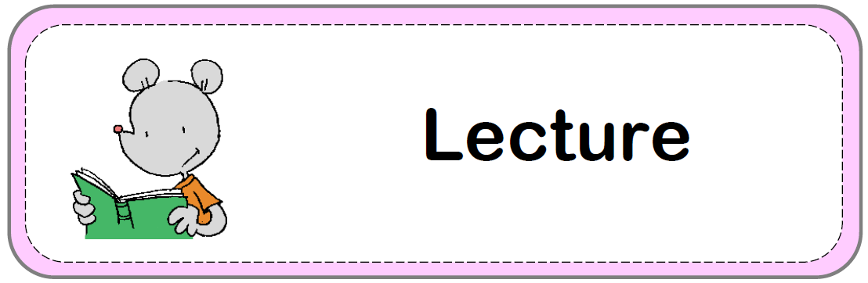

Storytelling

 



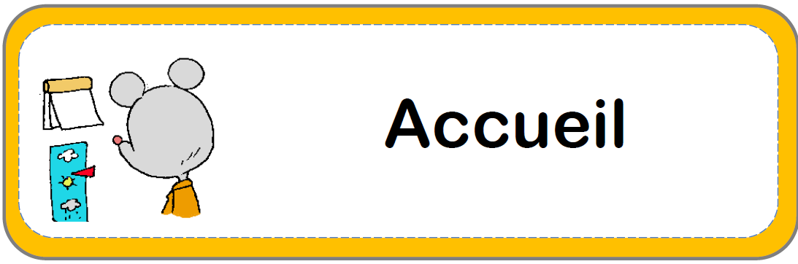

Morning Rituals

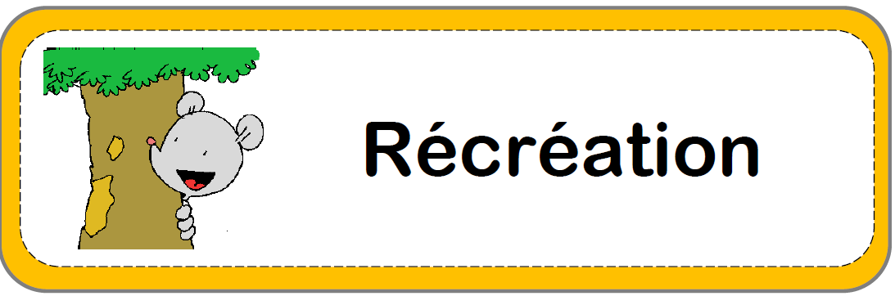

Recess



Recess

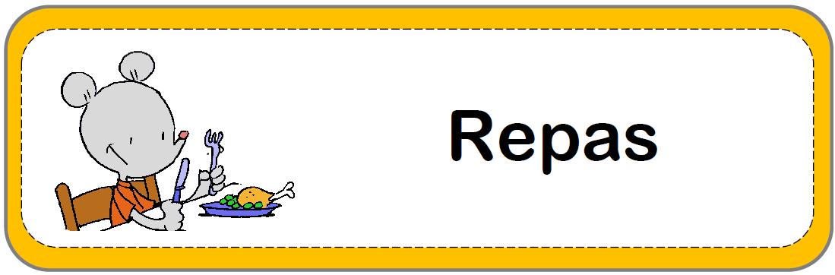

Lunch

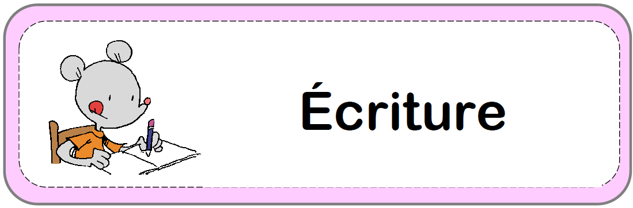

Writing

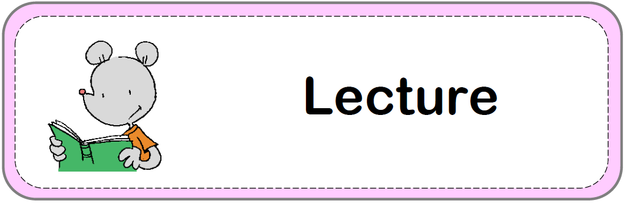

Reading

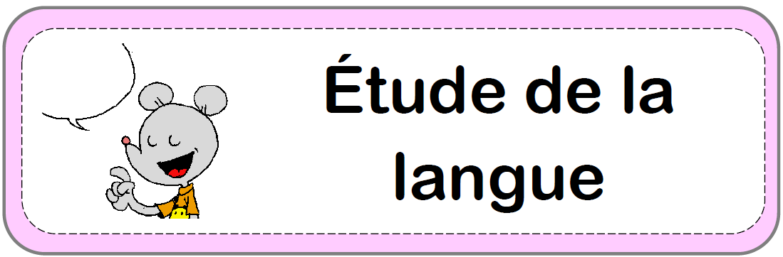

Phonology

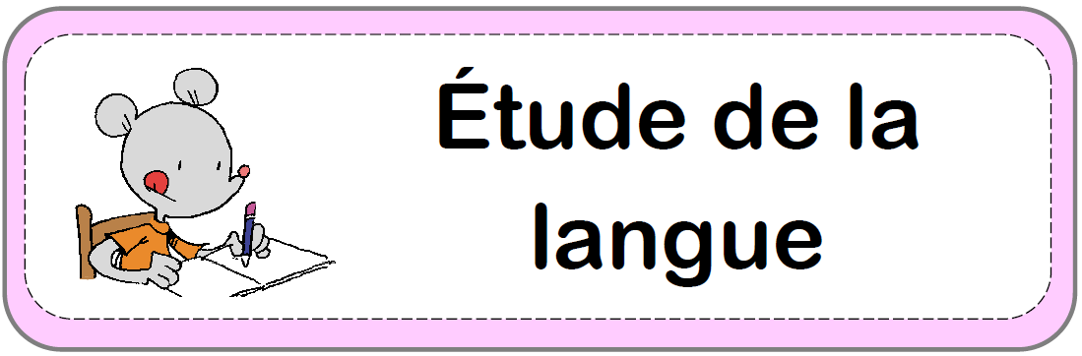

Language

Study

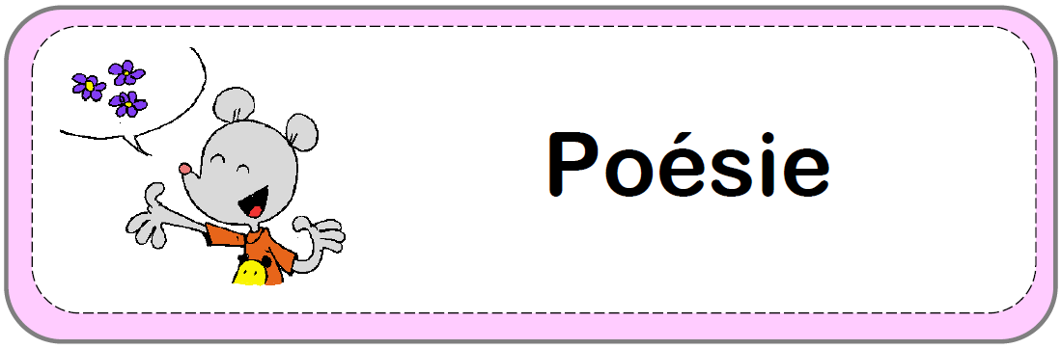

Poetry

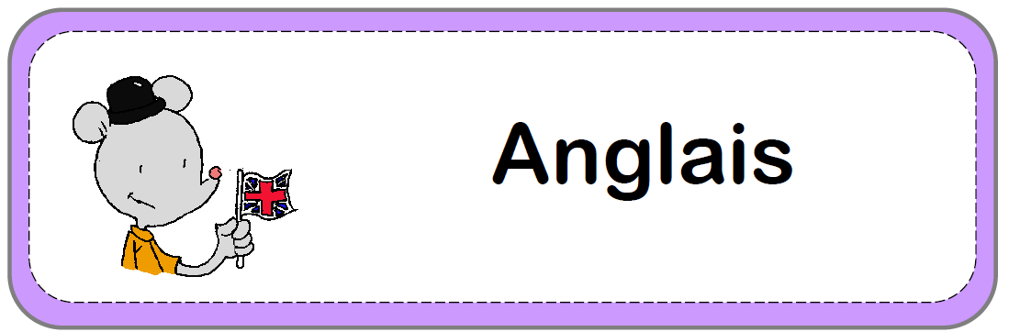

English

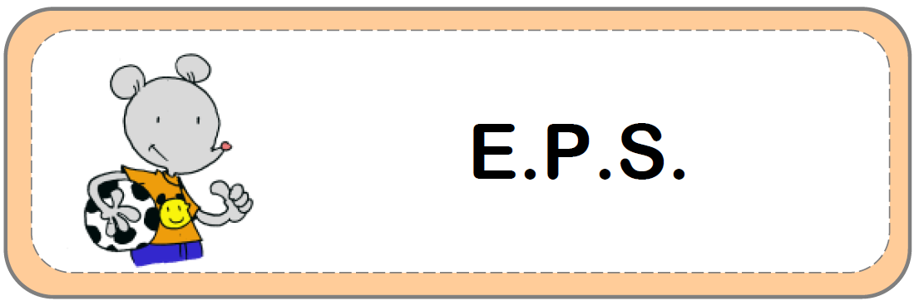

Physical

Education

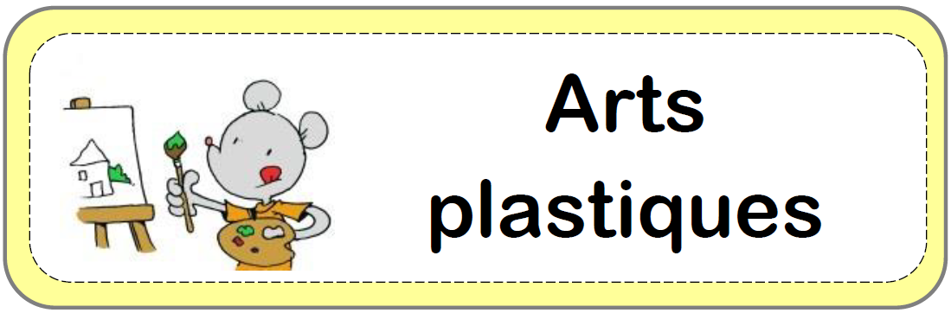

Art

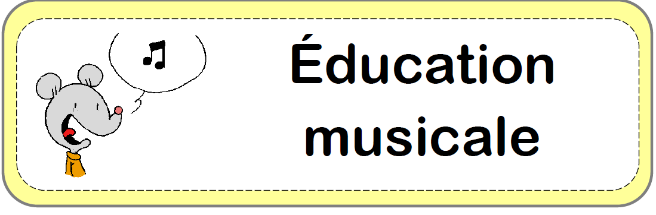

Music

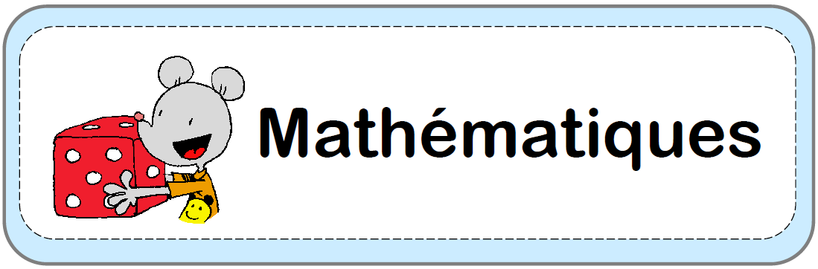

Mathematics

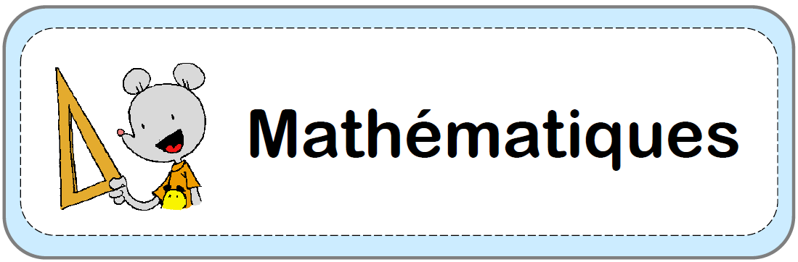

Geometry

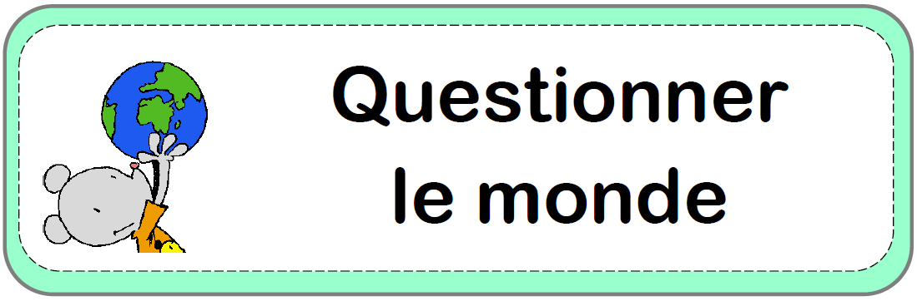

Question

the world

Question

the world

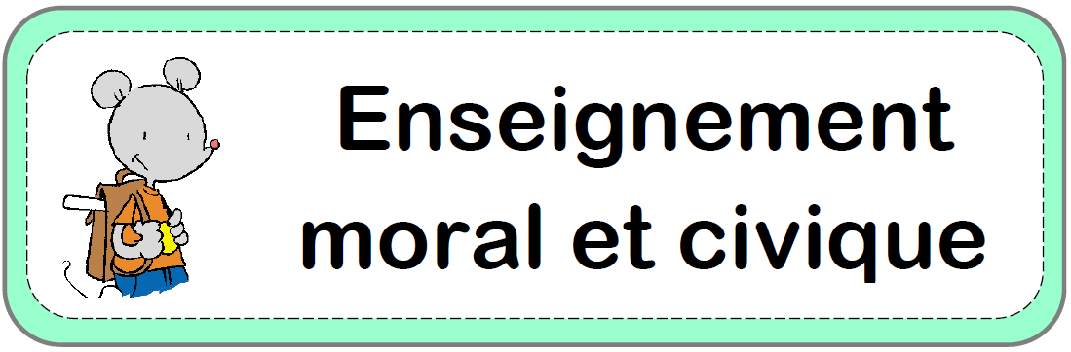

Moral and civic education

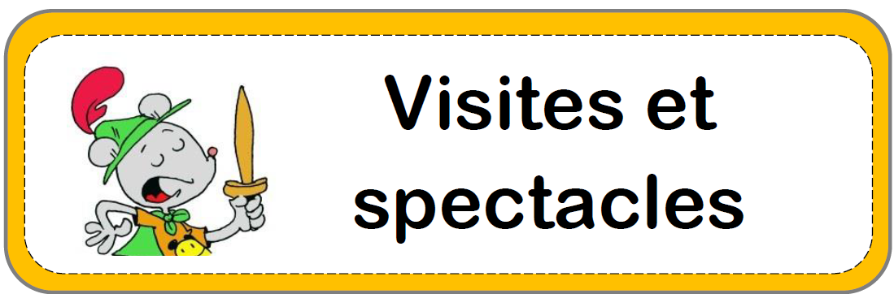

Visit

and show

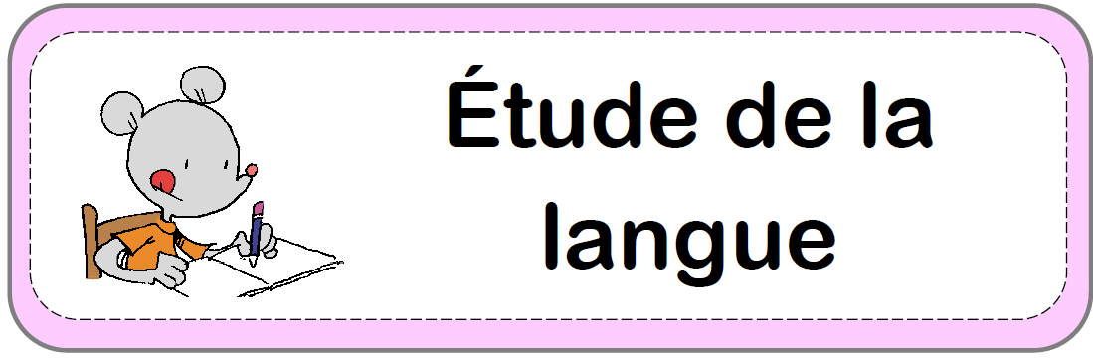

Dictation

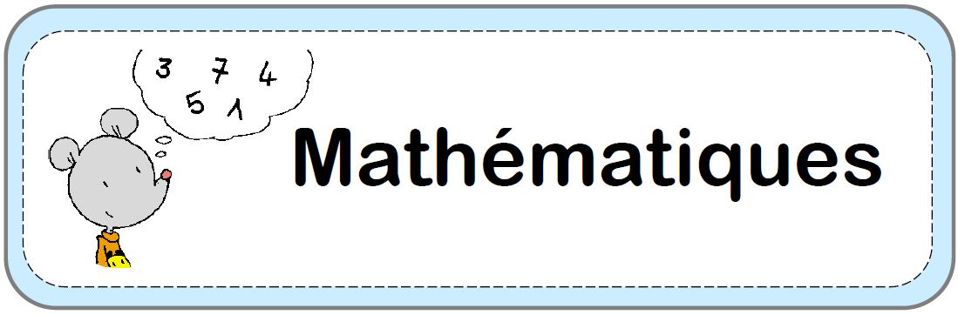

Mental

arithmetic

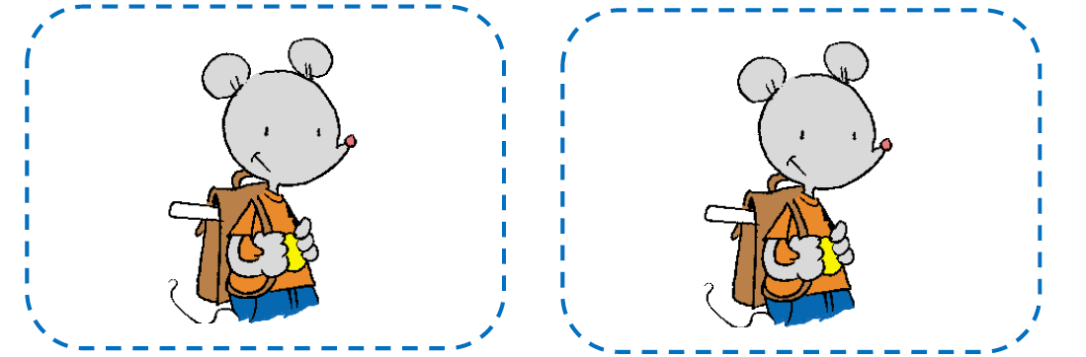

 

 



Games



Workshop